Exp-13:

In this demo, we are building a dashboard using Global Superstore 2017 Dataset.

Exp -13 – Solution

Step 1:

* Click on the Sheet Tab and rename it as Segment Wise Sales.
* Drag Sales field onto the Rows Shelf and drag Order Priority field onto the Filters & apply a filter by selecting All.
* Drag Segment field on to the Colors Shelf and as well as Label Shelf.
* Drag Sales field on to the Size Shelf.
* Drag Sales field on to the Label Shelf and apply quick table calculation of Percentage of Total.

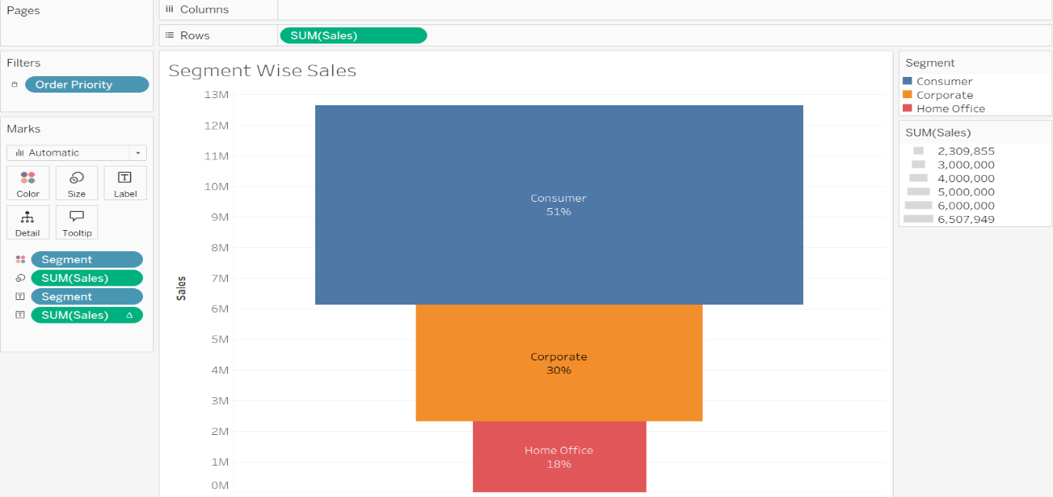

Step 2:

* Click on the Sheet Tab and rename it as State Wise Sales.
* Double click on State field
* Drag Order Priority field onto the Filters & apply a filter by selecting All.
* Drag Sales field on to the Colors Shelf and click on Colors Shelf then Edit Color & Select Red-Green-Gold Diverging.
* Drag State field on to the Label Shelf and as well as Detail Shelf.
* 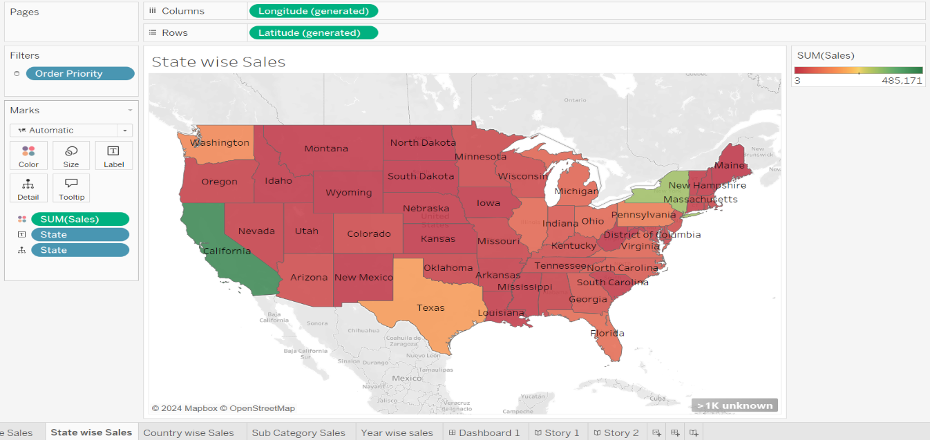Then Click on Unknown geographic locations & click Edit Locations Then Select Country/Region as United States.

Step 2:

* Click on the Sheet Tab and rename it as Country Wise Sales.
* Drag Order Priority field onto the Filters & apply a filter by selecting All.
* Drag Sales field on to the Colors Shelf and click on Colors Shelf then Edit Color & Select Orange-Blue Diverging.
* Drag Sales field on to the Size Shelf and Country filed on to the Text Shelf.
* 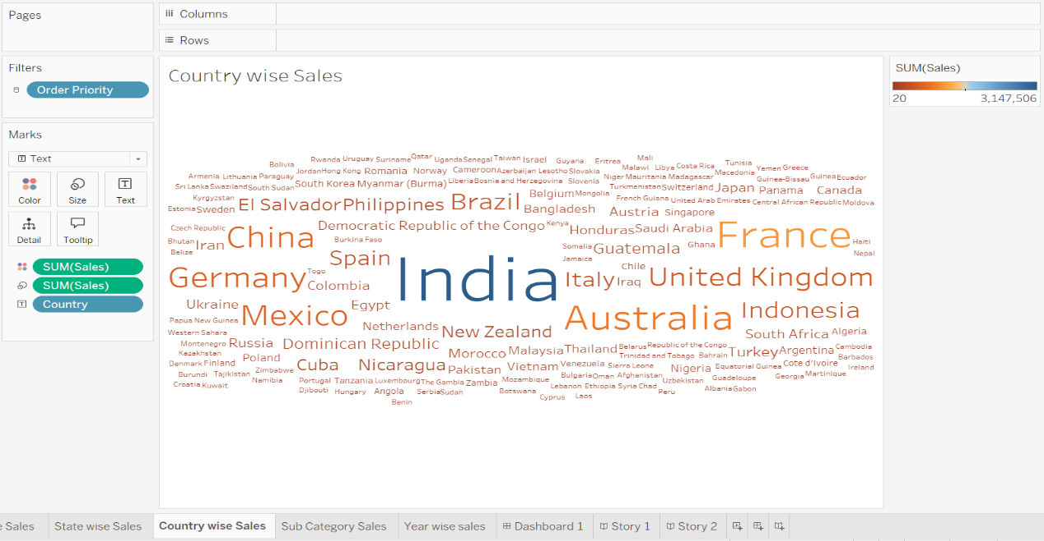Select Text chart option from the Marks Card.

Step 3:

* Click on the Sheet Tab and rename it as Sub Category Sales.
* Drag Order Priority field onto the Filters & apply a filter by selecting All.
* Drag Sales field on to the Rows Shelf.
* Drag Category field on to the Columns shelf.
* Drag Sub-Category field onto the Columns Shelf and Sort Sub-Category into descending order
* 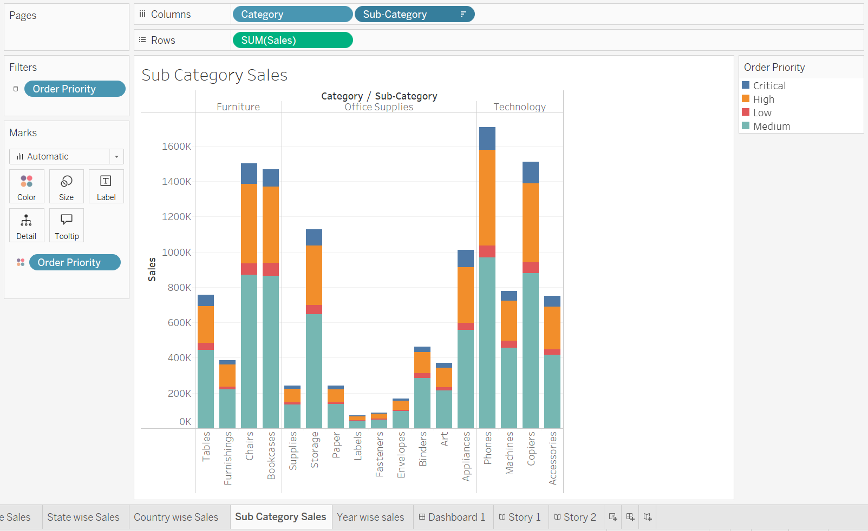Drag Order Priority field onto the Colors Shelf.

Step 4:

* Click on the Sheet Tab and rename it as Year Wise Sales.
* Drag Order Priority field onto the Filters & apply a filter by selecting All.
* Drag Order Date field on to the Columns shelf and make it continuous measure
* Drag Sales field on to the Columns shelf
* Drag Order Priority field onto the Colors Shelf
* 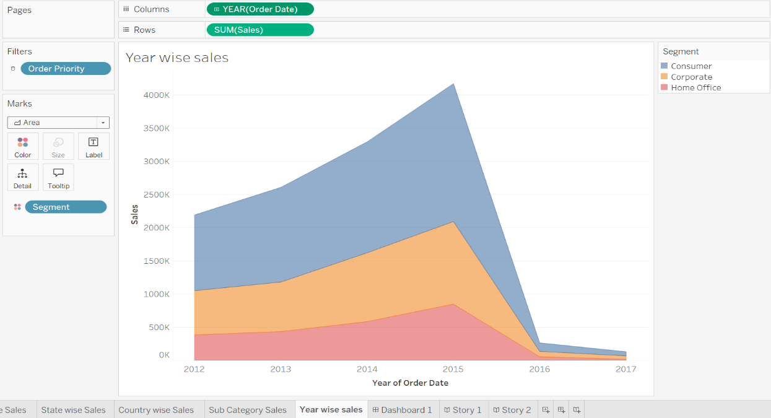Select Area chart option from the Marks Card

Step 5:

* Click the Dashboard Tab and then Change Size as Automatic From dropdown.
* Drag Segment Wise Sales sheet on to the view pane.
* Drag Sub Category Sales sheet on to the top of view pane.
* Drag State wise Sales sheet on to the top right of view pane.
* Click the Filter icon on the State wise Sales view
* 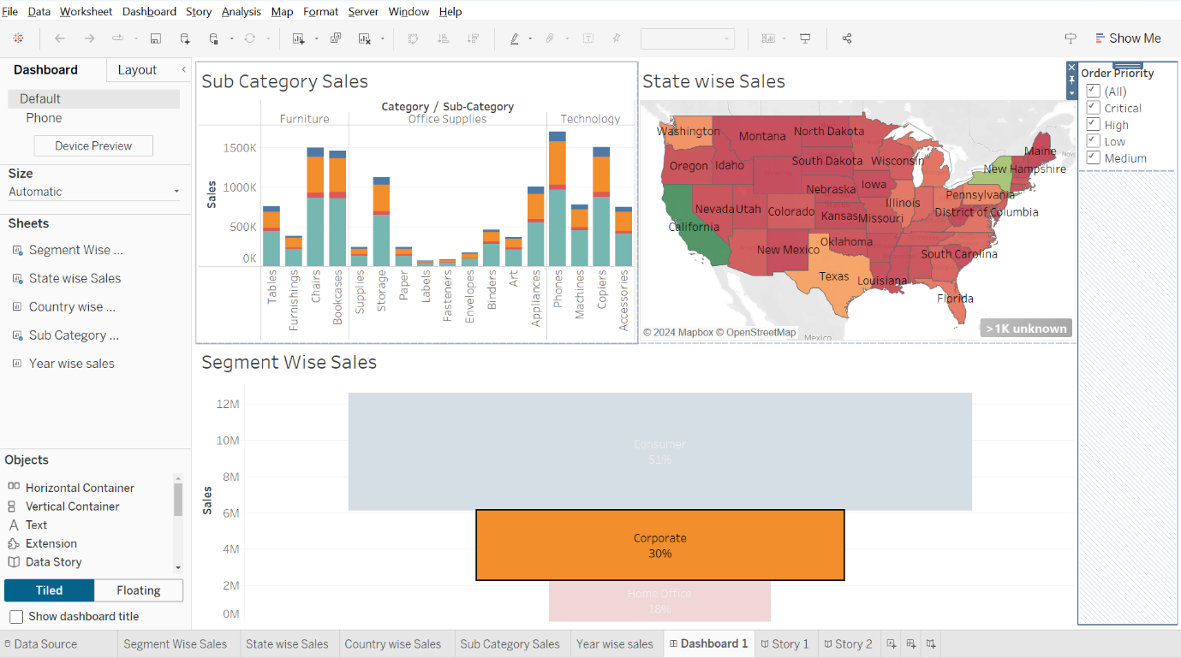Choose Filters → Order Priority to filter the views on the Dashboard based on Order Priority
* Click the drop down menu under Order Priority legend and choose Apply to Worksheets → All Using This Data Source option in order to apply the interactive filter to all the views using this Data Source.

Step 6:

* Click the Story Tab.
* Drag Segment Wise Sales sheet and drop it into the displays and click on this fixed size and I'll select as automatic. So, it will capture the entire space and automatically it will fit into this place.
* If I want to add some caption, I’ll just double click on this place and I can just keep on typing consumer sales is the highest.
* Now, if I want to add one more sheet or one more analysis in this place, simply I'll pick up this state wide sales and I can drop it before or after if you see the arrow keys which are given here if I put it before or after. So right now I'll put it after itself. And if you see now it is showing us the map graph.
* If I want to add some caption, I’ll just double click on this place and I can just keep on typing California has the highest sales among all states.
* simply I'll pick up this Country wise sales and I can drop it after itself. I’ll just double click on this place and I can just keep on typing India is good market for our products.
* simply I'll pick up this Sub Category Sales and I can drop it after itself. I’ll just double click on this place and I can just keep on typing Medium priority products are in high demand all across.
* simply I'll pick up this Year wise Sales and I can drop it after itself. I’ll just double click on this place and I can just keep on typing 2015 year has been a fantastic year among all.
* simply I'll pick up this Dashboard 1 and I can drop it after itself. I’ll just double click on this place and I can just keep on typing Interactive Dashboard.

